**Screen shot**

**Course-end Project 1**

**Automating Workloads Using ARM Template**

Step 1: create virtual machine or any resources

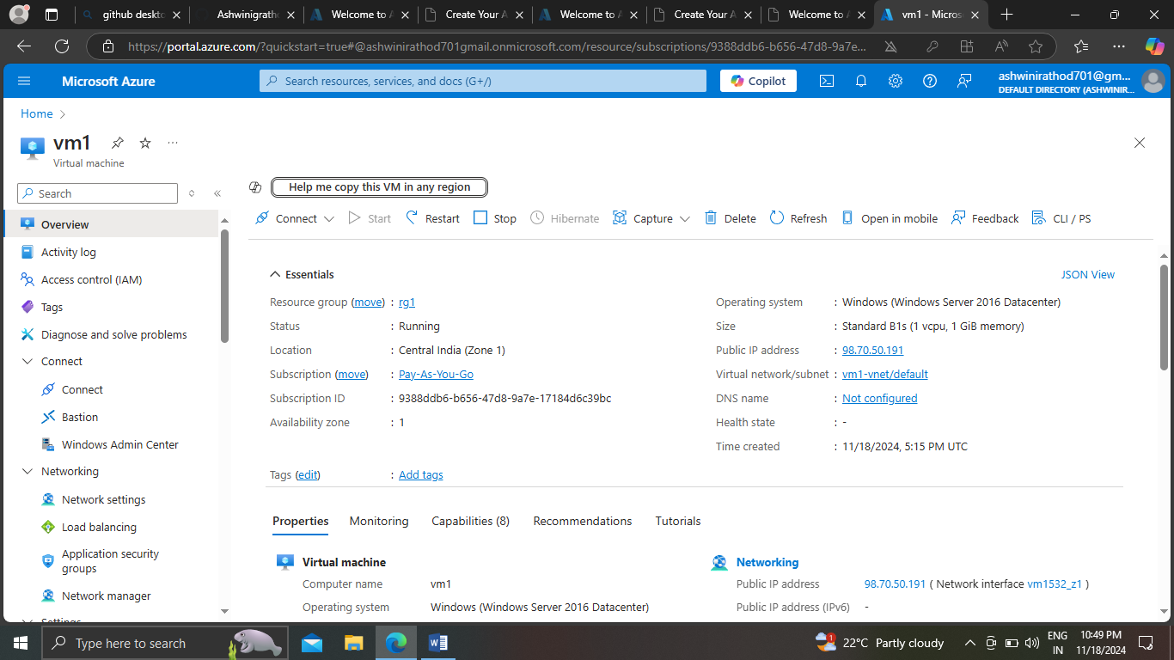

Step 2: download template from resource

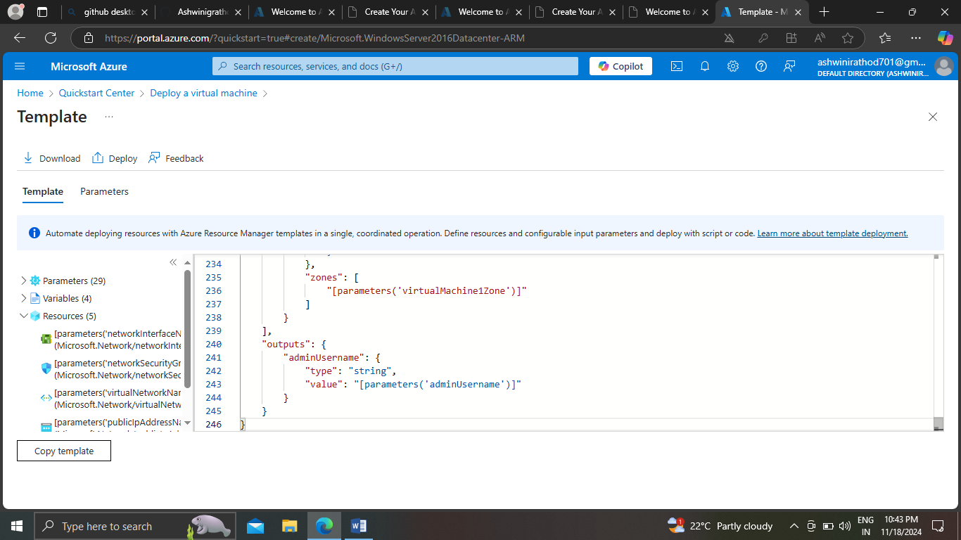

Step 3: create new Vm by custom deployment (template)

